**2cents™ Retail Point of sale**



Office No 2, City Building

8th Ave between R.Mugabe Str & G.Silundika Str

Bulawayo

Zimbabwe

0786404099

[2cents@byosoftware.co.zw](mailto:2cents@byosoftware.co.zw)

Table of Contents

Chapter 1: Introduction 3

Chapter 2: Installation 3

Minimum PC Specs: 3

Recommended PC Specs: 3

Installation Procedure 3

Chapter 3: Quick Start Guide 4

Employee Accounts / Login 4

The License / Activation 5

Customising The Settings 6

Chapter 4: The Toolbar 7

Landing Toolbar 7

Sale Toolbar 8

Refund Toolbar 9

Chapter 5: Processing Transactions 9

Chapter 6: Reports 10

**CHAPTER 1: Introduction**

This manual describes how to configure and use the 2cents™ Retail POS software. The order of chapters, follows the typical process from installation right up to performing the first sales transaction, and finally to the printing of reports.

2cents™ Retail POS is user friendly and most of its functions are intuitive / instinctive. This manual is just an overview.

If you feel that you need additional training, please contact support via email (2cents@byosoftware.co.zw) or via a call (0786404099).

We would be happy to assist.

**CHAPTER 2: Installation**

**Minimum PC specs:**

* OS: Windows 7/8.1/10 - 64-Bit/32-Bit
* Memory: 2 GB
* Hard Drive: 0.5 GB of free space

**Recommended PC specs:**

* OS: Windows 10 - 64-Bit
* Memory: At least 4 GB
* Hard Drive: At least 1.0 GB of free space

**Installation Procedure**

To install 2cents™ Retail POS you need to have an installation file, and a license key.

The installation file can be downloaded from www.2cents.co.zw. For Windows it is available as a self-extracting archive, which is named, for example 2cents_retail_pos_1.0.0.exe.

Double-click this file to initiate the installation. On the website you will always find the newest installation files.

A license key can be acquired from Byo Software or any of its sales agents. To get the contact details for Byo Software visit www.2cents.co.zw.

**CHAPTER 3: Quick Start Guide**

There are a few things that should be configured prior to processing any transactions.

Employee accounts / login

An employee account can have one of the following permissions: “**user**”, “**supervisor**” or “**manager**”.

**Users** can only perform sales transactions. The only reports they are able to print out, are their personal end of day reports (i.e. x-reports), which give a summary of all the sales transactions they have processed throughout the day.

**Managers** have access to all of the reports produced by 2cents™ Retail POS (*see reports section for a list of available reports*). They can also change the settings (*see the settings section for an overview*).

**Supervisors** have permission to do everything that users can do, plus some additional permissions they are given by managers, depending on the settings set.

2cents™ Retail POS comes with 2 default accounts. We encourage managers to create their own accounts, then delete the default accounts as soon as possible. The login credentials for the default accounts are listed below:

|  |  |  |
| --- | --- | --- |
|  | **Default Manager :** | **Default User :** |
| **Username** | manager | user |
| **Password** | password | password |

Managers can create new accounts, and edit existing accounts. You can use any managerial account to reset the password or pin for any other account.

If for some reason you are unable to access any of your managerial accounts, please contact Byo Software support.

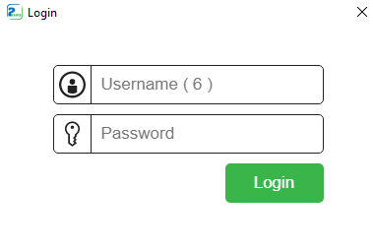Each time you launch 2cents™ Retail POS, you will be prompted to enter your login credentials. This is a security feature that cannot be deactivated.

If you are using the software for the first time, enter the default login credentials detailed in the section “Employee accounts / login” section.

The license / activation

In an effort to ensure you are happy with our product before you commit to a long term license, we offer a free non-obligation 1-month trial to all prospective customers.

If you are happy with our software, you can buy a 1-year license from Byo Software. Once used, a license key cannot be returned for a refund.

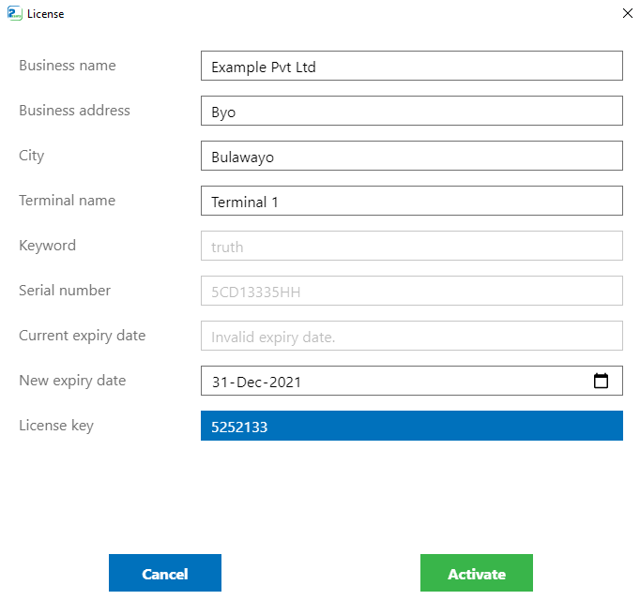Having installed the software and having acquired a licence key, navigate to the Licensing page by clicking “License” on the menu bar.

Once on the Licensing page, you have an opportunity to edit the business name, business address, city and terminal name.

This information will appear on the receipts, and can only be changed from the licensing page.

Input the “new expiry date” and the “license key” acquired from Byo Software and click “Activate”

Customising the settings

From the homepage, click on “settings” on the menu bar. Settings are divided into 8 sections or tabs.

1. 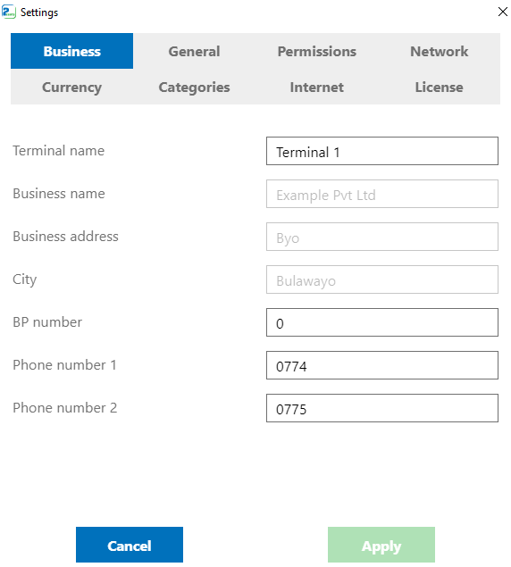*Business tab*

The Business settings tab has all of the business contact information fields. The business name, business address, city fields cannot be modified from the settings page. These fields appear on the receipt and can only be changed during product activation (when you enter the license key).

1. *General tab*

Under the general tab, is where you’ll find tax settings.

Here you can also toggle whether or not customers can be assigned to sales transactions.

The general settings tab also contains settings for some additional features e.g. The ability to sell ZETDC tokens, Econet airtime etc.

1. *Permissions tab*

Managers can control how much access users and supervisors have in the system via the settings contained under this tab.

1. *Network tab*

For 2 or more computers to share resources or information, they must be connected via a network. For client nodes the server IP address and port is set from the network tab.

1. *Currency tab*

2cents™ affords retailers the option to use multiple currencies for their transactions. Currency symbols and conversion factors can be changed from the currency settings tab.

1. *Categories tab*

A maximum of 20 categories can be defined for the items/products sold by the business.

1. *Internet tab*

These settings relate to external APIs.

1. *License tab*

Licence variables can be viewed from this tab. When requesting a license key from the Byo Software support team, these variables can be asked of you.

**CHAPTER 4: The toolbar**

The toolbar is a strip of buttons that can be clicked to perform certain functions. It is located at the top of the page. Different pages have different toolbar buttons.

The homepage has 3 different toolbars. At any given time only one of the toolbars can be seen.

|  |  |
| --- | --- |
|  | Appears when : |
| Landing toolbar | * the landing page is opened.  * after pressing the Void toolbar button. |
| Sale toolbar | * after pressing the Sale toolbar button.  * after a product is added to the cart. |
| Refund toolbar | * after pressing the Refund toolbar button. |

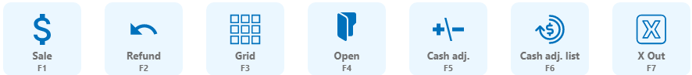Landing toolbar

1. *sale button*

Clicking the sale button signals the beginning of a sales transaction. The landing toolbar is replaced by the sale toolbar after this button is clicked.

1. *refund button*

Clicking the refund button signals the beginning of a refund transaction. The landing toolbar is replaced by the refund toolbar after this button is clicked.

1. *grid button*

The grid contains a selection of popular products. Clicking the grid button opens the grid page.

1. *open button*

This button is used to view saved transactions. From the list of saved transaction that appear, you can select a particular sales transaction that you want to open.

1. *cash adjustments button*

Everyone runs out of singles every now and again. Every time money is removed or added from the cash register you record the movement by first clicking the cash adjustment button.

1. *cash adjustments list button*

Clicking this button shows a record of cash drawer adjustments made by the employee that is currently logged in.

1. *x out button*

Clicking this button prints a report showing the sales transactions that have been processed by the employee since the beginning of the day.

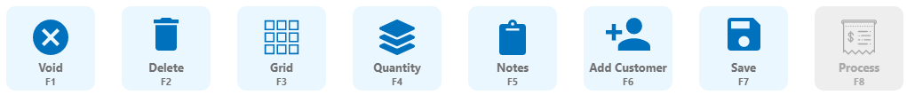Sale toolbar

1. *void button*

This button clears any transaction that is in progress and resets the system. The sale toolbar is replaced by the landing toolbar after this button is clicked.

1. *delete button*

Removes the highlighted/selected object from the ongoing transaction.

1. *grid button (see description in landing toolbar)*
2. *quantity button*

Opens the number pad that is used to change the quantity of the highlighted/selected item from the cart.

1. *notes button*

Opens a text pad that can be used to add notes to a transaction.

1. *Add customer button*

Is used to assign a customer to a transaction.

1. *save button*

Clicking this button saves the ongoing transaction. The sale toolbar is replaced by the landing toolbar after the transaction is saved.

1. *process button*

The sale button is grey at the beginning of a transaction. At this stage (when it is grey) it does not respond to clicks.

It turns green after items have been added to the cart and sufficient payments have been made. When the process button is green and clicked, the sales transaction is saved, and a receipt is printed.

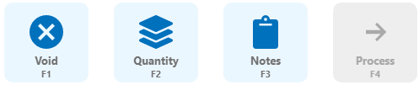Refund toolbar

1. *void button (see description in sale toolbar)*
2. *quantity button (see description in sale toolbar)*
3. *notes button (see description in sale toolbar)*
4. *process button (see description in sale toolbar)*

**CHAPTER 5: Processing transactions**

A user can perform 2 types of transactions: a sale or a refund. While sales can be processed by any user, refunds can only be processed by supervisors.

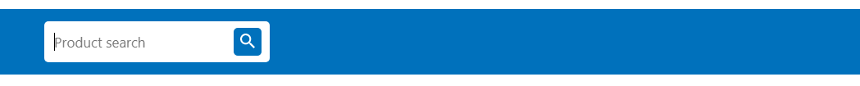

There are 3 ways to add an item to a transaction (sale or refund):

1. Scan an item using a barcode scanner
2. Search by item description in the “Product search” input field
3. Search by SKU in the “Product search” input field
4. Click the item from the Grid. The grid is accessed by pressing the Grid toolbar button.

Besides selecting from the grid (option 4), all other methods for selecting a product can only work when the focus is on the “Product search” field. The cursor in the “Product search” field should be blinking. A blinking cursor in the “Product search” field shows that the search field is in focus.

To add a customer to a transaction, click the “Add Customer” button in the toolbar.

After adding items to the cart, the next step is adding a payment.

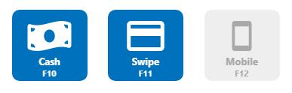

Active payment methods are blue while inactive payment methods are grey.

After clicking a payment method, an on-screen number pad is displayed. After the assignment of the payment types, click Process transaction. If a thermal printer is connected, the receipt is printed at this stage.

**CHAPTER 6: Reports**

2cents™ Retail POS has numerous reports. It also provides X-out and Z-out functionality. When a user performs an X out they receive a report showing the sales transactions they processed since the beginning of the day.

On the other hand, a Z out can only be printed by a supervisor or manager, and prints a report for sales transactions processed by the entire store (all employees included) on a particular day.

The names of the reports in the menu are very descriptive to assist in finding the report that you are looking for.

1. Transactions list
   * Detailed
   * Summarised
2. Sales reports
   * Detailed
   * Summarised
   * Refunds – by product
3. Customer reports
   * Detailed
   * Summarised
4. Supplier reports
   * Detailed – by supplier
   * Summarised – by supplier
   * Summarised – combined
5. Employee reports
   * Detailed
   * Summarised
   * Cash drawer adjustments
6. Inventory
   * Stocktake
     + Stocktake sheet
     + Stocktake results
   * Inventory report
     + Detailed
     + On hand adjustments
   * Goods received
     + All
     + By product
   * Goods reordered
     + All
     + Zero on hand report
   * Popular products
     + Top 10 best sellers
     + Top 25 best sellers